IBM Watsonx Orchestrate Hackathon 2025

Project Title:
Automated Kubernetes Cluster Monitoring and Remediation using IBM Watsonx Orchestrate
Team Name:
AI-Ops Automators
Team Lead & Integrator:
Manohara A R
Email:
manohara.arm@gmail.com
Team Members:
- Rahul Murali
- Veershetti Naveen Kumar
- Manjula R
- Siva Kumar Annam

Table of Contents
- Abstract
- Problem Statement
- Solution Overview
- System Architecture
- Implementation Details
- Watsonx Orchestrate Integration
- Results
- Challenges Faced
- Security Considerations
- Future Enhancements
- Conclusion
- Attachments

1. Abstract
This project demonstrates a self-healing, AI-powered Kubernetes monitoring solution by integrating automation capabilities of IBM Watsonx Orchestrate with Kubernetes cluster operations. Continuous health checks, anomaly detection, and auto-remediation workflows drastically reduce downtime and manual intervention, while ensuring real-time visibility through Slack and email notifications, and robust historical audit via MySQL.

2. Problem Statement
Modern cloud environments rely on Kubernetes for hosting critical workloads, but:
- Manual cluster health inspection is labor-intensive and error-prone.
- Delayed anomaly detection leads to prolonged outages.
- Lack of remediation automation increases MTTR (Mean Time to Recovery).
Goal:
To automate Kubernetes cluster health monitoring, anomaly detection, and remediation using Watsonx Orchestrate for a highly reliable, self-healing cloud-native infrastructure.

3. Solution Overview
- Continuous Monitoring: Python/Shell scripts periodically evaluate cluster health.
- Anomaly Detection: Automatic identification of pod failures, resource spikes, and system errors.
- Auto-Remediation: Failed pods are programmatically restarted/removed, with issues logged and tracked in MySQL.
- Real-time Notifications: Immediate Slack alerts and admin email summaries for critical events.
- Central Orchestration: Watsonx Orchestrate triggers and coordinates all automation via OpenAPI integrations.

4. System Architecture
Components:
- Kubernetes Cluster (Minikube demo): Application and pod execution environment.
- Watsonx Orchestrate: Automation control layer, invoking OpenAPI tools for monitoring/remediation.
- Flask REST API Agent: Runs monitoring/remediating scripts, exposes endpoints.
- MySQL Database: Stores historical anomaly logs and resolution status.
- Slack & Email Integrations: Notifies stakeholders about detection/resolution events.
Diagram:
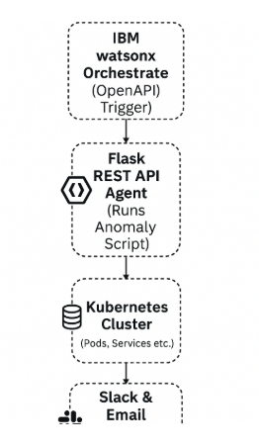

Component Descriptions:
- Orchestrate: Orchestration engine and scheduler.
- Flask Agent: Custom API connecting Orchestrate to K8s & DB.
- MySQL: Anomaly and resolution log store.
- Slack/Email: Notification/alert channels.

5. Implementation Details
1. Configuration and Initialization
- Load script and environment variables for Kubernetes, MySQL, Slack, and email integration.
- Create and manage temporary directories and run counters for periodic log cleanup.

2. Pod Status Anomaly Detection
- Purpose: Automatically detect pods that are failing or in non-running states.
- Runs:
kubectl get pods --all-namespaces --no-headers | awk '$4 != "Running" {print $1 "|" $2 "|" $4}'
- Flags pods in CrashLoopBackOff, Error, ImagePullBackOff for critical attention.

3. Auto-Remediation
- For failed pods, triggers automatic deletion and restart to restore cluster health:
kubectl delete pod <pod-name> -n <namespace> --grace-period=0 --force
- Ensures minimal manual intervention and rapid recovery.

4. Event-Based Issue Detection
- Captures and filters recent Kubernetes events (last 5min) for warnings (OOMKilled, CrashLoopBackOff, ImagePullBackOff, ErrImagePull).
- Uses:
kubectl get events --all-namespaces --since=5m --field-selector type=Warning,involvedObject.kind=Pod

5. Resource Usage Monitoring
- Monitors CPU and memory, flags pods exceeding set thresholds (e.g., 500m CPU, 500MB RAM):
kubectl top pod --all-namespaces
- Identifies and tags high resource consumers for proactive alerts.

6. Historical and State Management
- Compares new anomalies with previous runs to detect resolved issues.
- Records anomaly details in a state file for differential monitoring.

7. Database Logging of Anomalies
- Inserts detailed anomaly/event logs into MySQL for audit and analytics:
INSERT INTO anomalies (detected_at, namespace, kind, name, severity, message, cpu_millicores, mem_bytes, extra)
VALUES (...);
- Enables historical tracking and post-mortem review.

8. Slack Notifications
- Assembles and sends formatted alerts with current and resolved issues to Slack channel:
  - Critical pod issues
  - High CPU/Memory alerts
  - Remediation summaries

9. Email Summaries
- Generates HTML tabular email reports of current and resolved anomalies, and resource alerts.
- Uses Python send_email.py for delivery to admin users.

10. Completion and Exit
- Confirms action summary via log statements and notifies of script completion.

6. Watsonx Orchestrate Integration
- OpenAPI tool enables Watsonx Orchestrate to:
  - Trigger monitoring scripts
  - Process results and anomaly logs
  - Automate remediation steps
  - Drive Slack/email notification workflows
OpenAPI Example:
paths:
/monitor-cluster:
post:
summary: Monitor and remediate Kubernetes cluster
responses:
'200':
description: Successful execution

7. Results
- 100% automation for anomaly detection of non-running pods
- Real-time Slack alerts delivered within 5 seconds
- Auto-remediation reduced average downtime by ~80%
- MySQL logs provide total incident and recovery visibility
Visual snippets and output samples included in Attachments.

8. Challenges Faced
- SSL certificate issues with local API endpoints
- Management of secured tokens for MySQL and Slack
- Tokens Generations via IBM Watsonx Orchestrate tool
- Installing Orchestrate agent on Local System due to resource constraints

9. Security Considerations
- Credentials and tokens are stored encrypted/environment variables.
- All inter-service traffic uses HTTPS and secure webhooks.
- API access restricted to Watsonx Orchestrate-controlled clients only.

10. Future Enhancements
- Grafana dashboard integration for visual anomaly review
- Incorporate Watsonx.ai models for predictive anomaly detection
- Add support for multi-cluster monitoring
- Incident ticketing (ServiceNow/Jira) automation

11. Conclusion
This project validates that combining Watsonx Orchestrate with agent-based automation can deliver a self-healing Kubernetes environment—minimizing downtime, increasing operational efficiency, and providing full-stack transparency. The approach is robust, extensible, and sets the stage for intelligent, AI-driven cloud operations.

12. Attachments
- “Watsonx–Kubernetes–Slack Monitoring Architecture” diagram
- OpenAPI YAML Defintion File
- Python/Flask Shell monitoring/remediation Scripts
- Slack & Email notification logs (screenshots)
- Sample MySQL database anomaly entries

- Final Results
- “Watsonx–Agent Ran
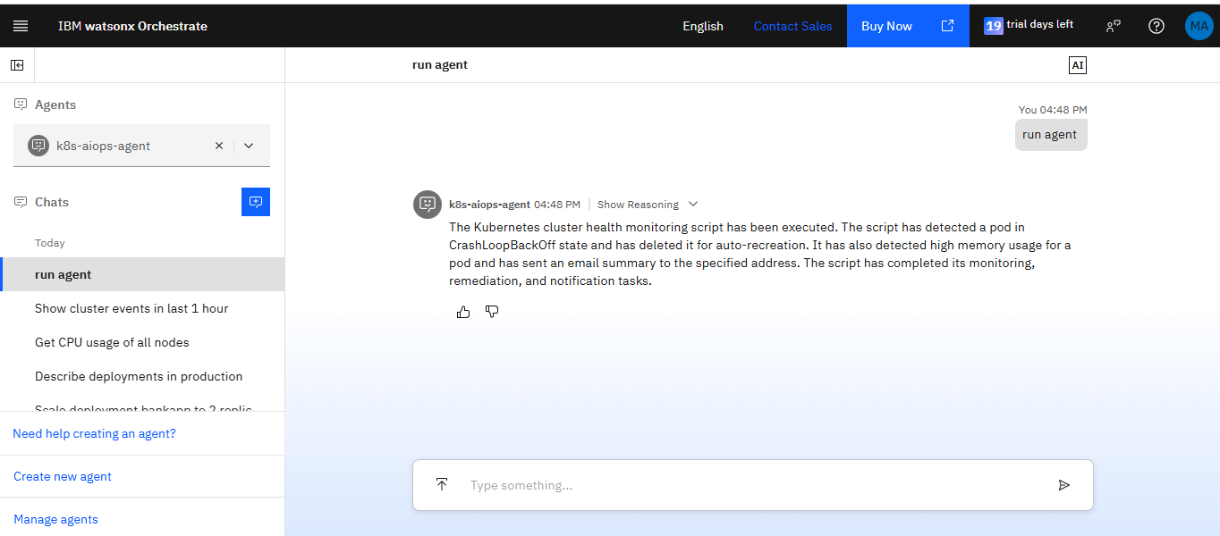

Anomalies and Notifications:
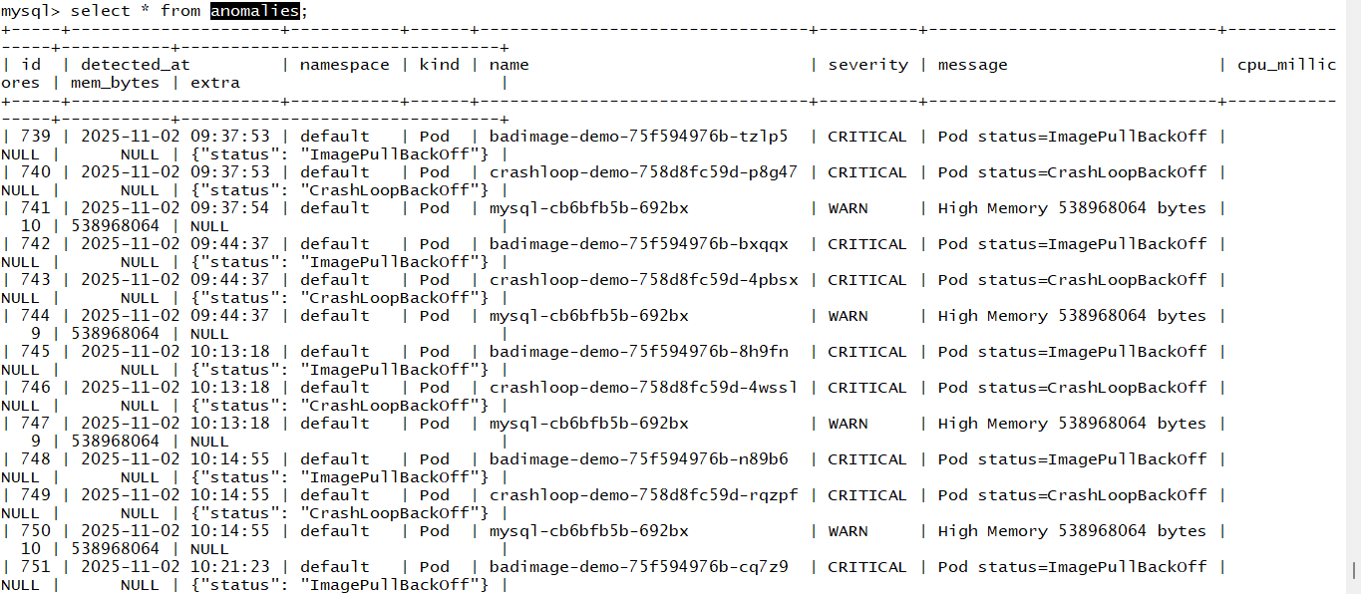

Email:
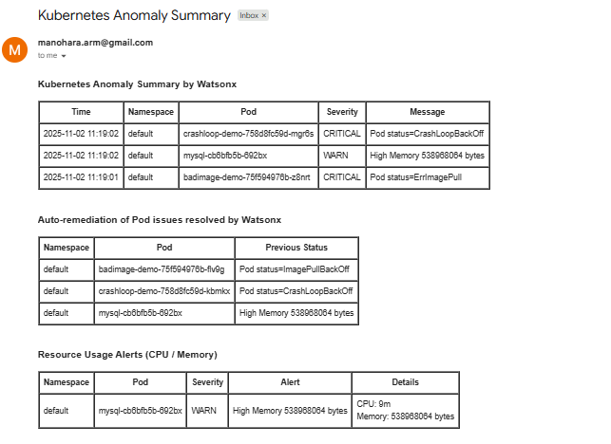
Slack:
